Apple Productivity
 | Pages | Free with new iPad
 | Keynote | Free with new iPad
 | Numbers | Free with new iPad
 | Books | Free with new iPad
 | GarageBand | Free with new iPad
 | Safari | Free with new iPad
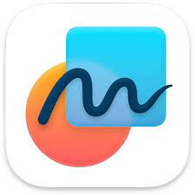 | Freeform | Free with new iPad
Microsoft Productivity
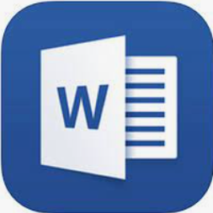 | Word | Free for EQ students
 | PowerPoint | Free for EQ students
 | Excel | Free for EQ students
 | OneDrive | Free for EQ students
 | Teams | Free for EQ students

Art and Drawing
 | Pencil Box | Free
 | Tayasui Sketches School | Free

Mathematics
 | Number Rack | Free
 | Number Pieces | Free
 | Fractions | Free
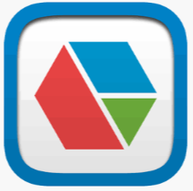 | Pattern Shapes | Free
 | Geoboard | Free
 | Number line | Free
 | Math Clock | Free
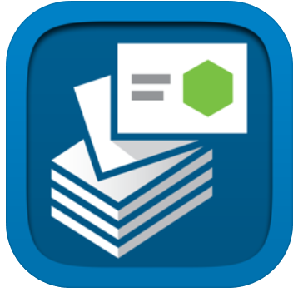 | Math Vocab | Free
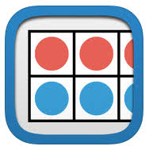 | Number Frames | Free
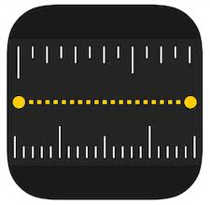 | Measure | Free with new iPad
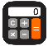 | Calculator | Free
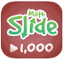 | Math Slide: Hundreds, Tens and One | Free
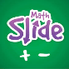 | Math Slide: Addition and Subtraction | Free
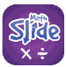 | Math Slide: Multiply and Divide | Free
 | Mathletics | Free  *subscription

Photo and Video
 | Clips | Free with new iPad
 | iMovie | Free with new iPad
 | iMotion | Free
 | Photo Booth | Free with new iPad
 | Photos | Free with new iPad
 | Camera | Free with new iPad
 | PicCollage | Free
 | AR Makr | Free

Literacy
 | Reading Eggs | Free  *subscription
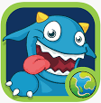 | Literacy Planet | Free  *subscription
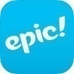 | Epic | Free
 | iBrainstorm | Free
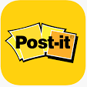 | Post-it | Free
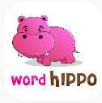 | Word Hippo | Free
 | Popplet LITE | Free
 | SORA

Travel
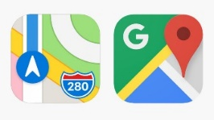 | Maps | Free
 | Google Earth | Free

Other
 | Quizlet | Free
 | Kahoot It | Free
 | Socrative Student | Free
 | Seesaw Class | Free
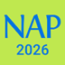 | NAP locked down browser  2026 | Free

Wellbeing
 | Smiling Minds | Free

Japanese
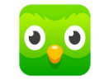 | Duolingo | Free
 | Japanese-Hiragana | Free
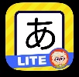 | Dr. Moku’s Hiragana Mnemonics LITE | Free

*Subscription included in Student Resource Scheme. If not participating in SRS, then individual subscription must be purchased.

